**HTML | <script> src Attribute**

Last Updated : 02 Jun, 2022

The **HTML <script> src Attribute** is used to specify the URL of external JavaScript file. The External JavaScript file is used to run on the same script on several pages on a website. We can save the JavaScript file with an extension of .js. We can refer the external script using the src attribute of the <script> element.

**Syntax:**

<script src="URL">

**Attribute Values:** It contains single value URL which specifies the URL of the external JavaScript file. There are two types of URL link which are listed below:

* **Absolute URL:**It points to another webpage.
* **Relative URL:** It points to other files of the same web page.

Below example illustrates the <script> src attribute in HTML:

**Example:**

* HTML

|  |
| --- |
| <!DOCTYPE html>  <html>    <head>      <title>      HTML  script src Attribute      </title>  </head>    <body style="text-align:center;">      <h1>          GeeksForGeeks      </h1>        <h2>          HTML script src Attribute      </h2>        <script id="myGeeks"              type="text/javascript"              src="my_script.js">      </script>      <br>      <button>Submit</button>    </body>    </html> |

**Output :**

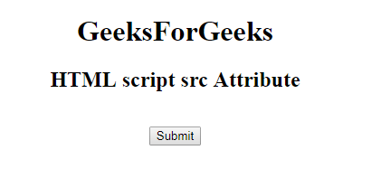

**Supported Browsers:** The browser supported by HTML <script> src attribute are listed below:

* Google Chrome 1 and above
* Edge 12 and above
* Firefox 1 and above
* Internet Explorer
* Safari
* Opera

Dive deep into the world of JavaScript with our [JavaScript Full Course Online](https://www.geeksforgeeks.org/courses/javascript?utm_campaign=three_90_345_abt&utm_medium=gfgcontent_abt&utm_source=geeksforgeeks), offering everything from the basics to advanced techniques. Learn how to build interactive websites, optimize your code, and earn a certification to showcase your skills.  
  
Take the **Three 90 Challenge**! Complete **90% of the course** in **90 days**, and **earn a 90% refund**. Push your limits and stay motivated as you work towards mastering JavaScript. Join now an